

You will need to set up a Repl.it account to run code in an environment that runs JavaScript

Steps to set up

- Go to https://replit.com/
- Sign up with your email address
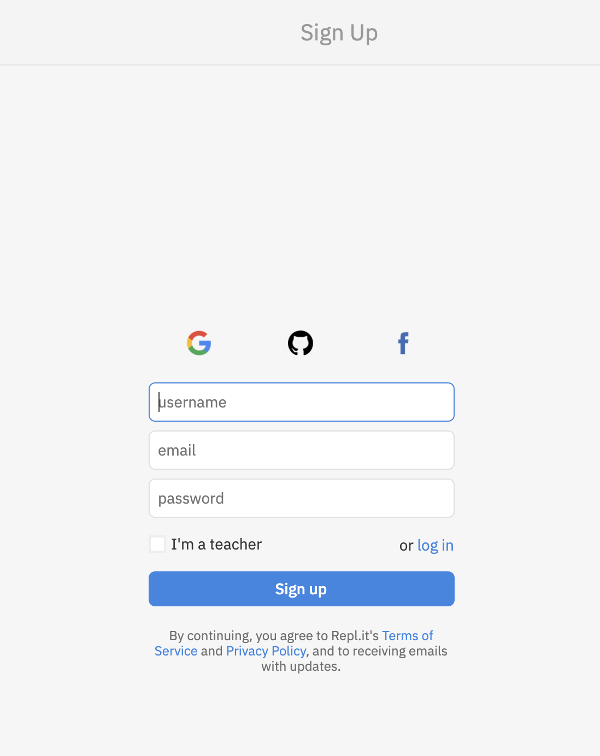

- Once you sign up, please go to https://repl.it/languages/javascript
You will see this screen. Please write your name in the right option, and click on create repl button
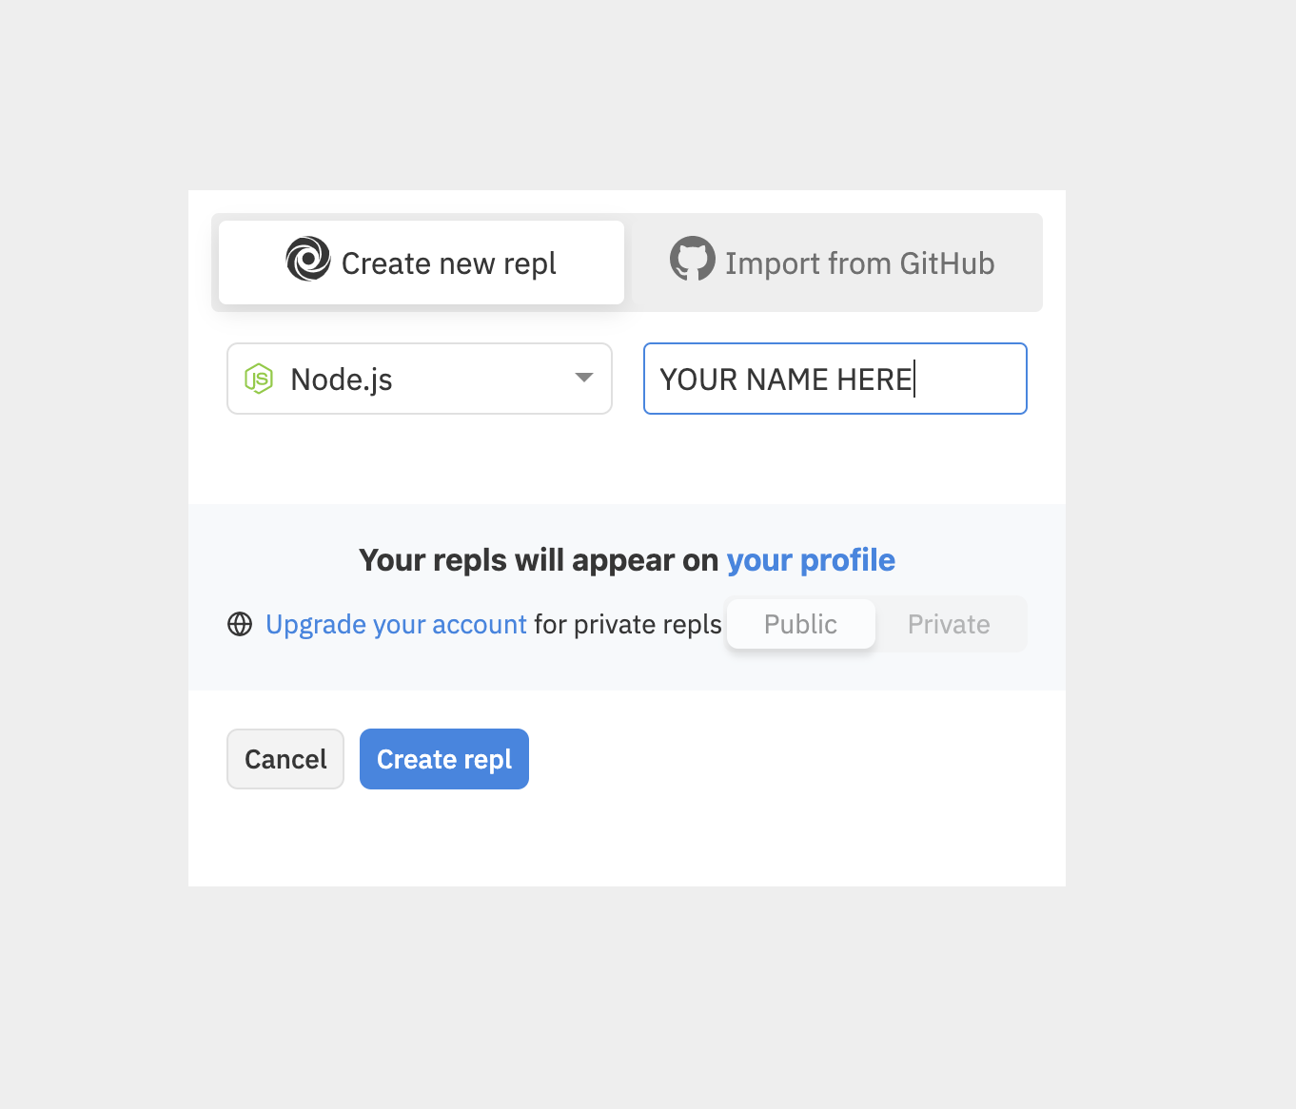

- Once you are in your environment, you will see something like this.
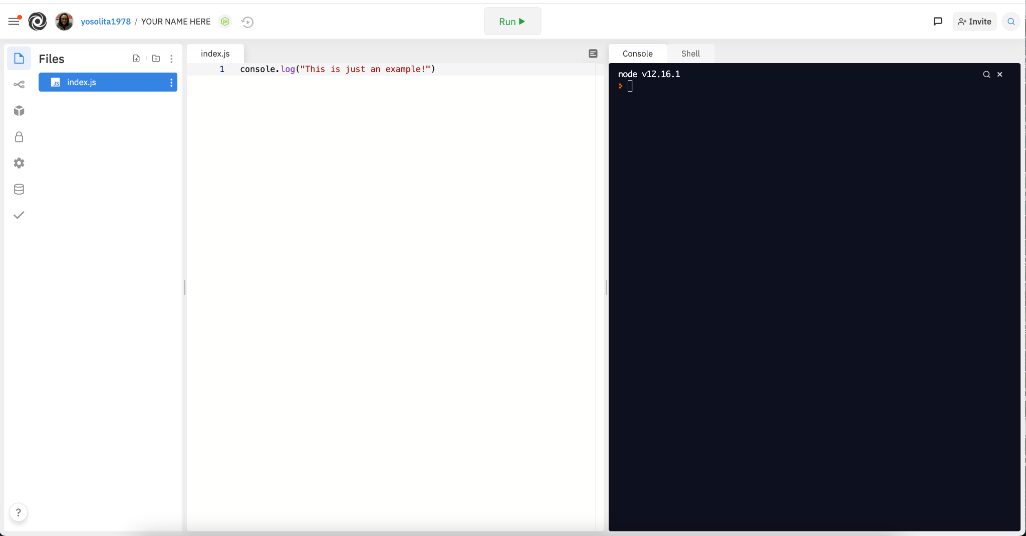

Now you can start to work on your code.
You need to type your code in the file index.js
For testing and running your code, just click on the “Run” button on the top of the screen.

